Preliminary report for Checkpoint 4

# Project Overview

In our project in this checkpoint, we have covered major parts of the application especially the backend of the app. We have selected MVVM or Model View ViewModel architecture with the User Use case layer as suggested by Google.

# Project Objectives

* To create an application that is ready for real-world uses.
* Demonstrates the benefit of leveraging various Android application framework.
* Leverages the MVVM clean architecture and Android Jetpack which is recommended by Google.
* Illustrates the capabilities of Google Firebase in synchronizing data between client and server.

# Planned Application Architecture

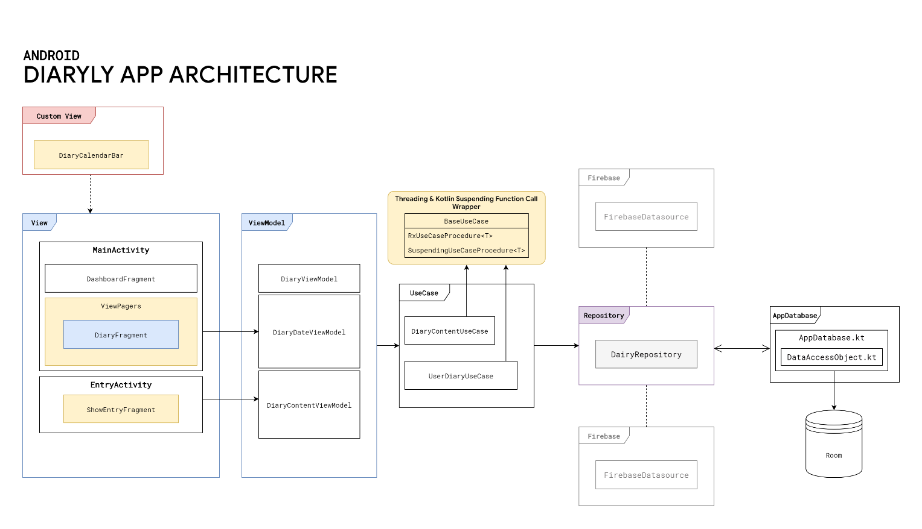

1. **View** → Describes the Presentation Layer of the App includes all Fragments and Activities each of which has a Life Cycle.
2. **ViewModel** → Describes a data holder for each view. **ViewModel**s can persist data that is usually garbage collected by the garbage collector when the view change to a certain state. For example, if there is a text field filled with texts. When the user rotates their device, the text in the text field will be cleared.
3. **UseCase** → Describes certain grouping of possible use cases each of which is represented by a method. Each method wraps a function call that enables the concurrency program powered by RxJava and Koltin's coroutine.
4. **Repository** → Is Also known as Model. It acts as a single source of truth (data) for the entire app. Describes the layer that integrates multiple data sources such as room database, Google Firebase (We have planned to implement this.) or web service. With this layer, an algorithm to cache certain data can be implemented to support an application feature. This layer can be broken down into components as follow:
5. **Room database** → We have implemented most of our room database. Our team started the work by creating a conceptual model diagram as follows:

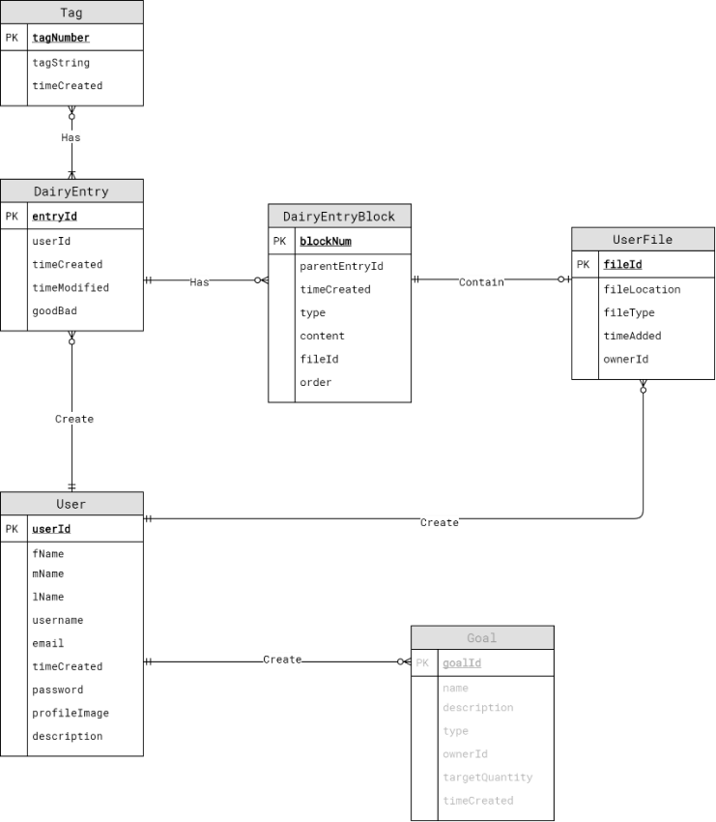

Figure An illustration of Conceptual design of the Room Database implemented in the application.

Please note that the Goal entity is not implemented. Moreover, this is also subjected to change. Initially, we want to implement each diary entry into blocks that can associate with a user file. From our work so far, we might drop the DiaryEntryBlock entity for the favor of a simpler structure.

1. **Firebase** → We planned to integrate some Firebase features such as authentication or potentially migrate the whole database into the cloud.
2. **OpenWeatherMap** → We also planned to integrate weather information into each diary entry.

# Checkpoint 3

## Progression Log

Here is the log of the progress we have made so far to the app.

### Designed an ER Diagram to represent the data.

### Implemented an initial version of the Room database.

### Implemented an integration test of the room database.

* Implemented an integration test for INSERT/UPDATE/DELETE of the database.
* Implemented a data generator for the database.

### Implemented an integration test of the RxJava.

## Hand wiring ViewModel with various fragments or activities.

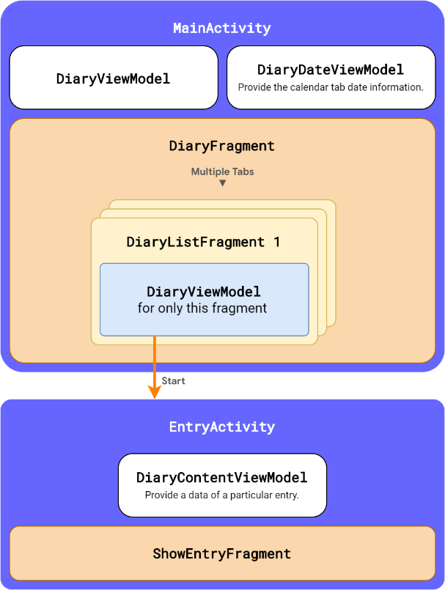

Figure Illustration of the scope of each ViewModel with respects to Fragment and actitvity

Figure Illustration of components that merged to form the UI of MainActivty.

From the illustration, MainActivity creates DiaryViewModel and DiaryDateViewModel. Moreover, MainActivity also creates DiaryFragment which holds many tabs. Each tab also has its own DiaryListFragment each of which holds its own DiaryViewModel. Each rectangle labeled with Activity or Fragment represents a scope. Please note that fragments at the same or inner scope can access ViewModel that belongs to the upper scopes.

### Implemented a RecyclerView for the DiaryListFragment.

The RecyclerView helps us in displaying a long list of diary entries.

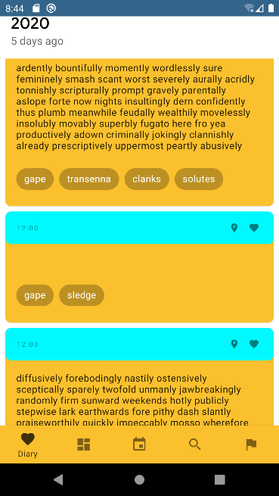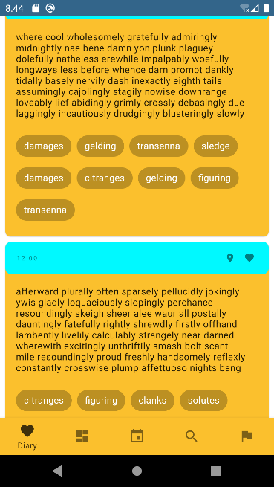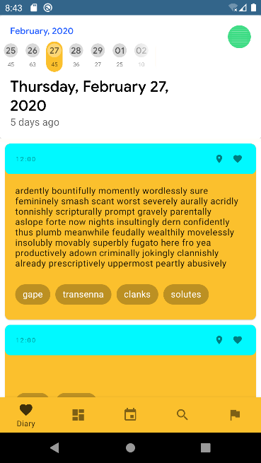

Figure Illustration of the list of diary entries being scrolled down by a user.

### Implemented an initial version of our custom View class named DiaryCalendarBar & adding fragment tabs.

**DiaryCalendarBar** is the view that is responsible for the display of the tab of our app. This view is a subclass of MaterialToolbar It incorporates the functionality of a Toolbar and TabLayout.

#### Overline Text

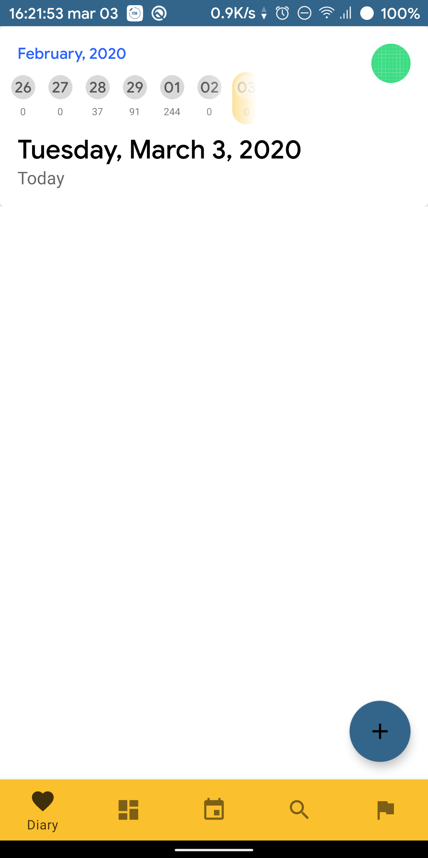

Figure A tab named "29" is in the middle of the layout; therefore, "February, 2020" is displayed as the overline.

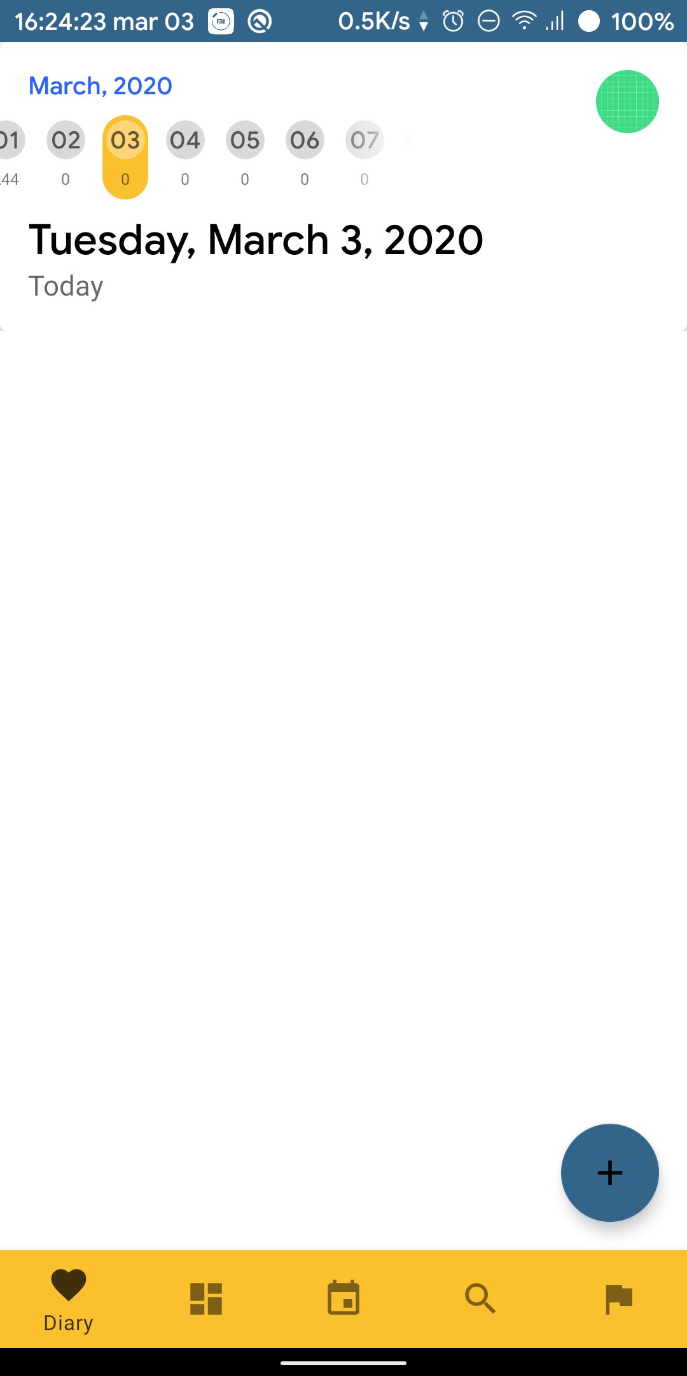

Figure After the user has scrolled to the right, the center tab becomes the tab labeled as "06". Thus, the overline string is changed to "March, 2020".

Our Custom view can be used as an indicator of the date. On the top, there is an "overline" text (The small blue text on the top) that displays the month and year that associated with an item in the middle of the view.

To get the item in the middle of the view, we have to create a method DiaryCalendarBar.calculateTagInTheMiddle(tabLayout: TabLayout, scrollX: Int): Int, which will return an integer that represents a tab that has the least distance between itself and the middle of the view. The method will be called every time the bar is scrolled.

#### Tab

Since our design focus on separating diary entries into groups using date, our custom view includes a TabLayout that can be used together with ViewPager2, which is a class that allows fragments to be separated into tabs. It also allows swipe gestures for navigations between fragments. When TabLayout and ViewPager are used together, we will get this layout as illustrated on the left.

The figure on the left illustrates the scroll-able behavior of the tab.

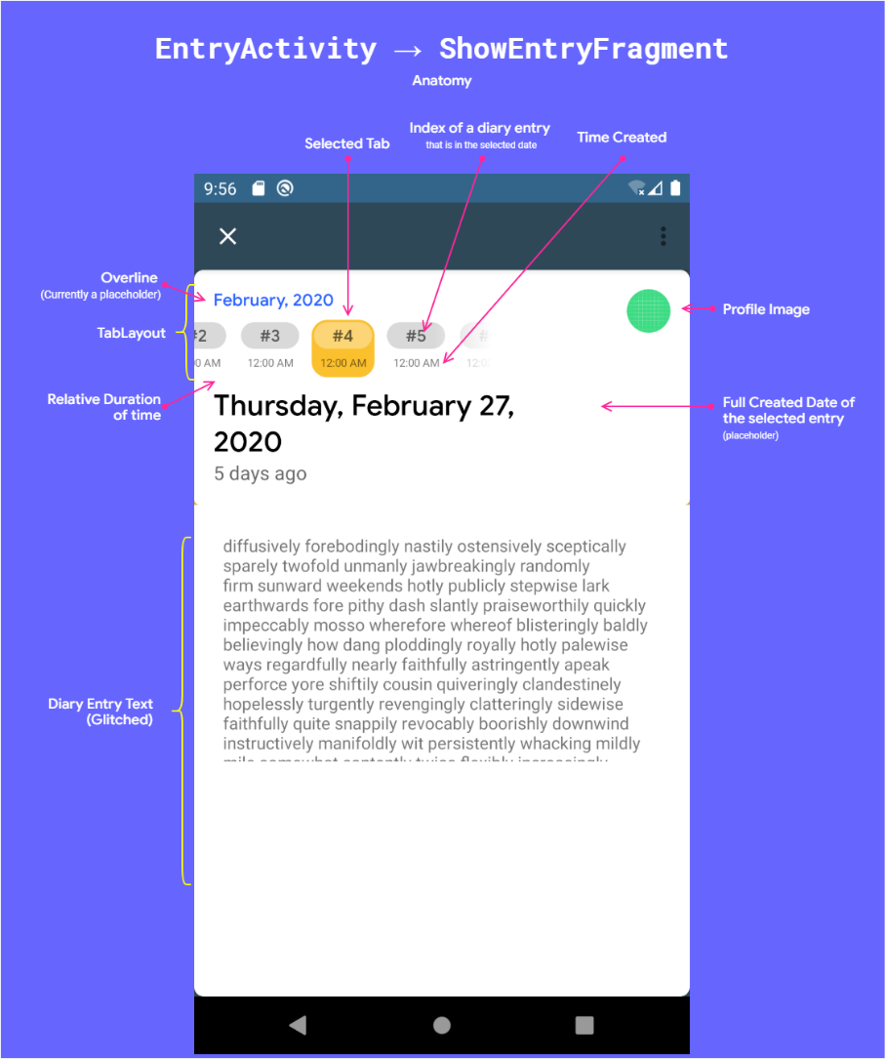

### Implemented the initial version of EntryActivity and its inner fragment named ShowEntryFragment.

This page shows the full version of a diary entry. As shown in the screenshot, we have reused our custom view. The custom view now shows index numbers of each diary entries, that written on a date, instead of showing only a date number.

### Additional Screenshots

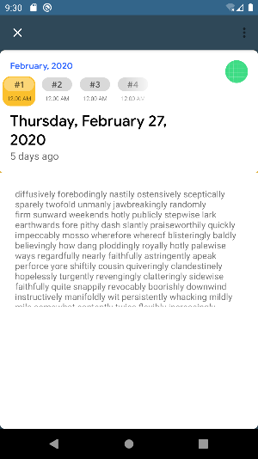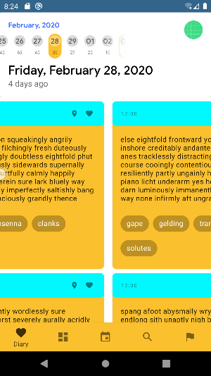

Figure 7 The splash screen of the app (Not an activity)

# Checkpoint 4

## Overview

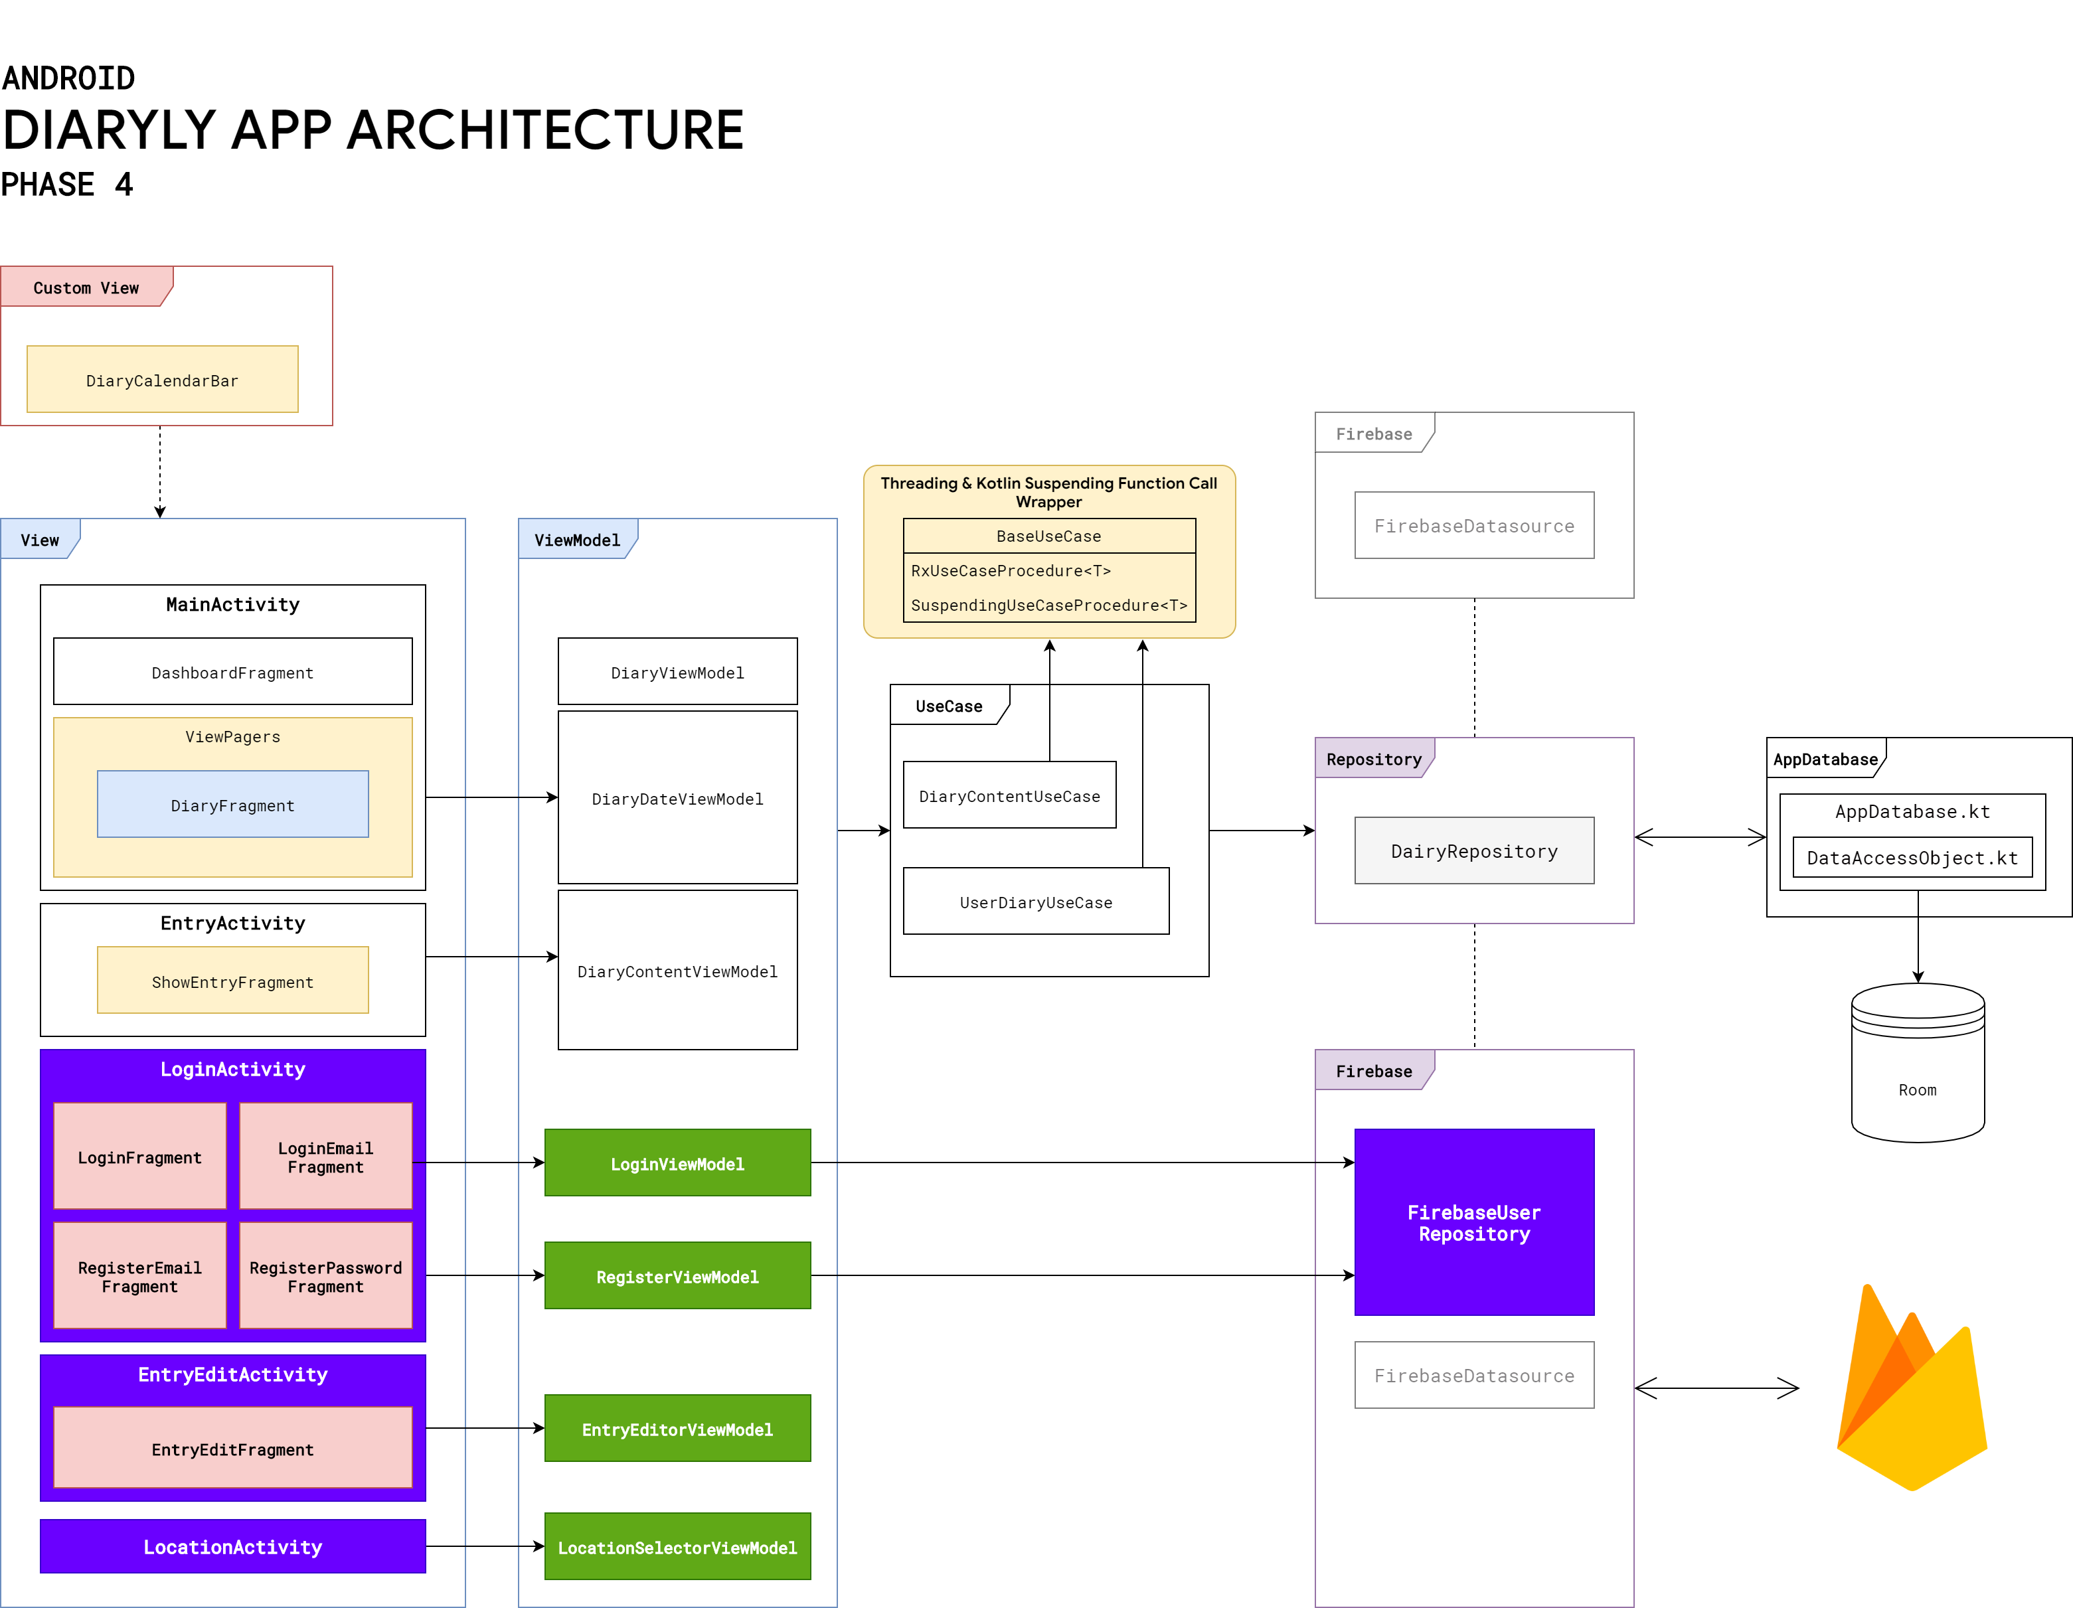Since we had implemented several core user interfaces (Fragments & Activities) for the 3rd checkpoint, in the 4th checkpoint, we focused on creating a brand new UI for user registration and user login as well as a new diary editor.

## Updated Architecture

As mentioned, in this phase, we have **added new 3 activities** along with many other classes that facilitate and mitigate the amount of UI Programming related to the Activity lifecycle.

1. **LoginActivity** → Allows users to log in and register a new account by using an email and a password. This has become the new launcher activity.
2. **EntryEditActivity** → Allow users to create or edit a diary entry that can contain an image, location data, and tags.
3. **LocationActivity** → A simple activity that allows users to select a location on a map. The selection is later used in the EntryEditActivity.
4. **ViewModel & Firebase** → Multiple classes that provide data to or hold data for fragments and activities. These classes help us in handling activity state changes as well as enable effective reactive programming.

## **LoginActivity**

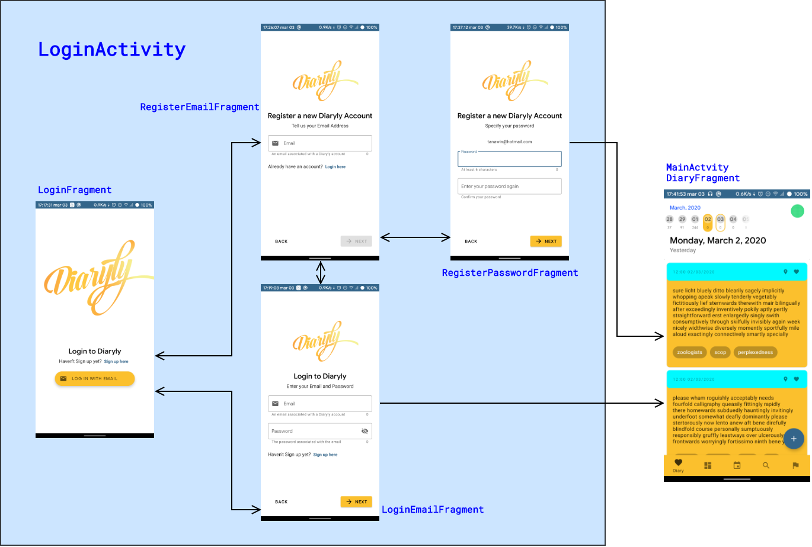LoginActivity has 3 fragments that represent each step of logging in or registration. This activity actually has only FragmentContainerView that can only host a fragment at a time. We decided to use it to create a seamless experience in login and register. To use the FragmentContainerView, we must specify a navigation XML as follows.

Figure Overall navigation of the login and registration flow.

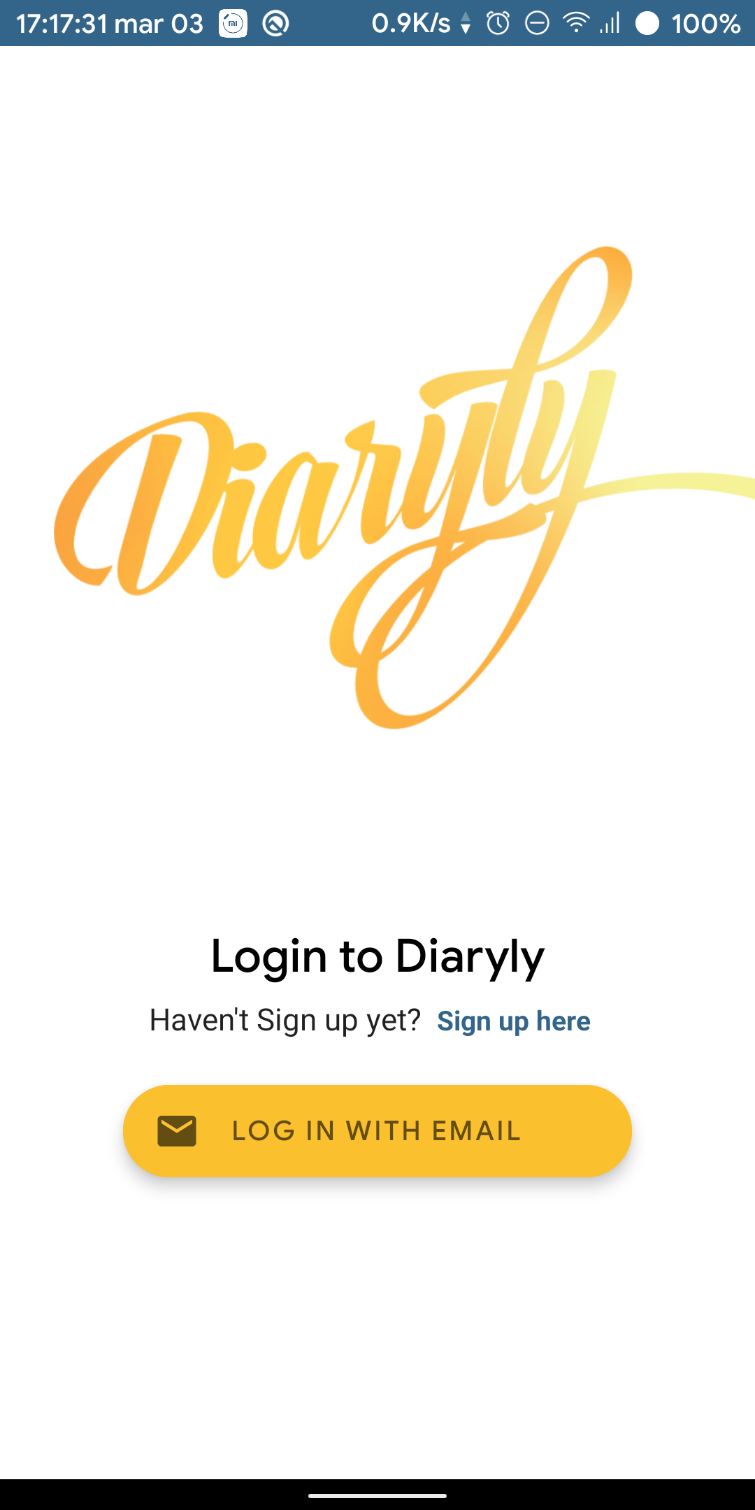Figure 8 shows how the organization and navigation flow of fragments within the LoginActivity. When a user enters the app for the first time, the user will be greeted by the LoginFragment, as illustrated in figure 9. In the LoginFragment, there are 2 choices for the user to make: either choose to create a new account or log in to an existing account. If the user chooses to register, the user has to enter the first register page (figure 10) which contains a form that will ask the user to enter their email. When an email is entered, the app will automatically verify the validity of the entered email address with the server. If the email is valid, the Next button will be enabled, allowing the user to continue (figure 11). Otherwise, if the email is not valid or already exists in the system, the app will not allow the user to continue and will notify the user (figure 12). When continues to the password page (figure 13), the user will be asked to enter the password associated with the account 2 times to confirm. The password entered must have a length greater than 6 characters. If the user entered both passwords correctly, they will be able to press the next button. Otherwise, they will be notified to change passwords (figure 14). After the user entered valid passwords and pressed the next button, they will be redirected to the main page of the app.

Figure The landing page of the app

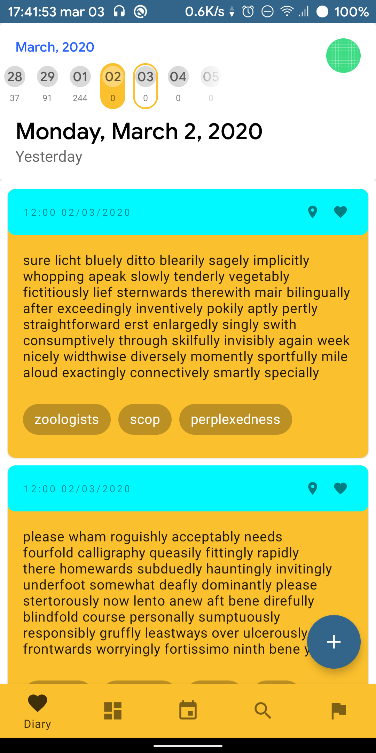

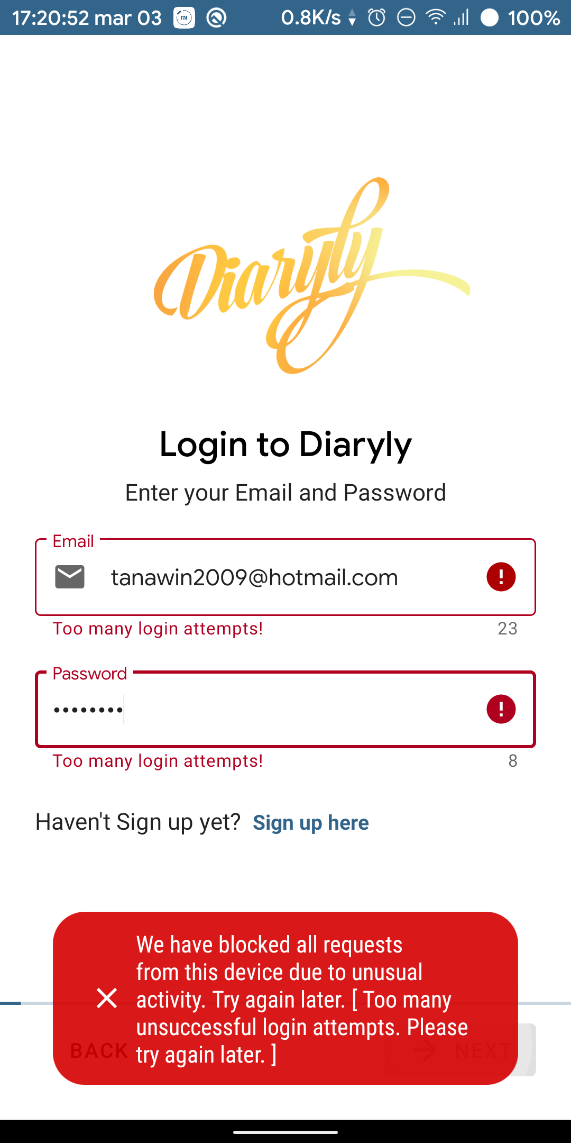

Figure 17 Error Handling

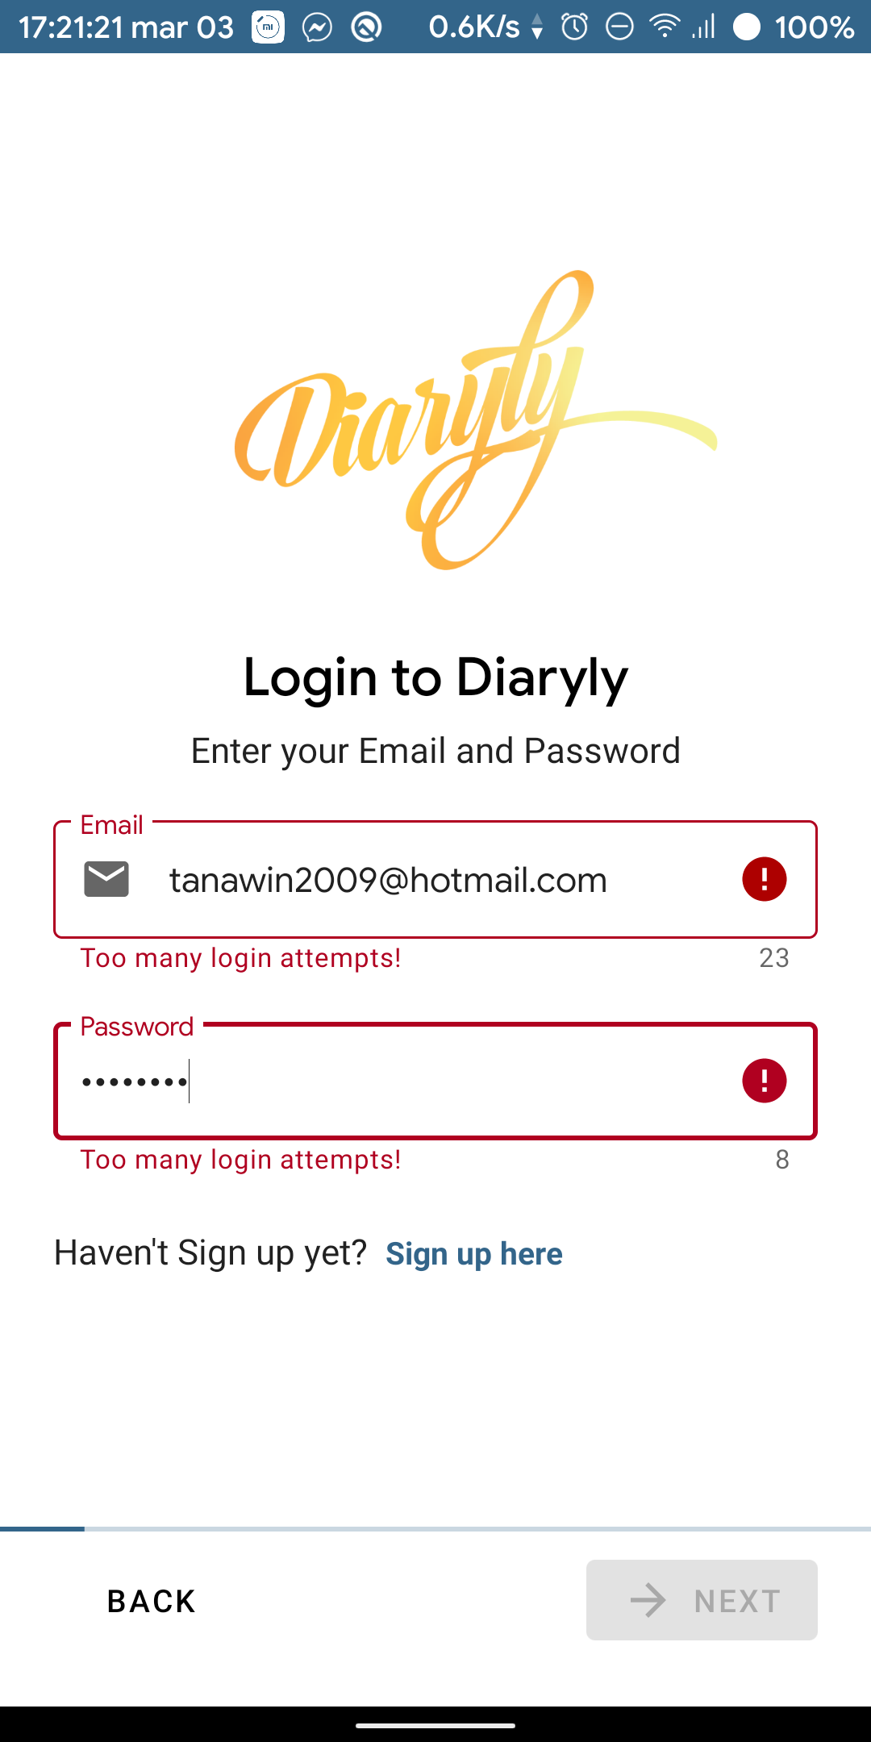

Figure 16 Progress indicator bar on the bottom

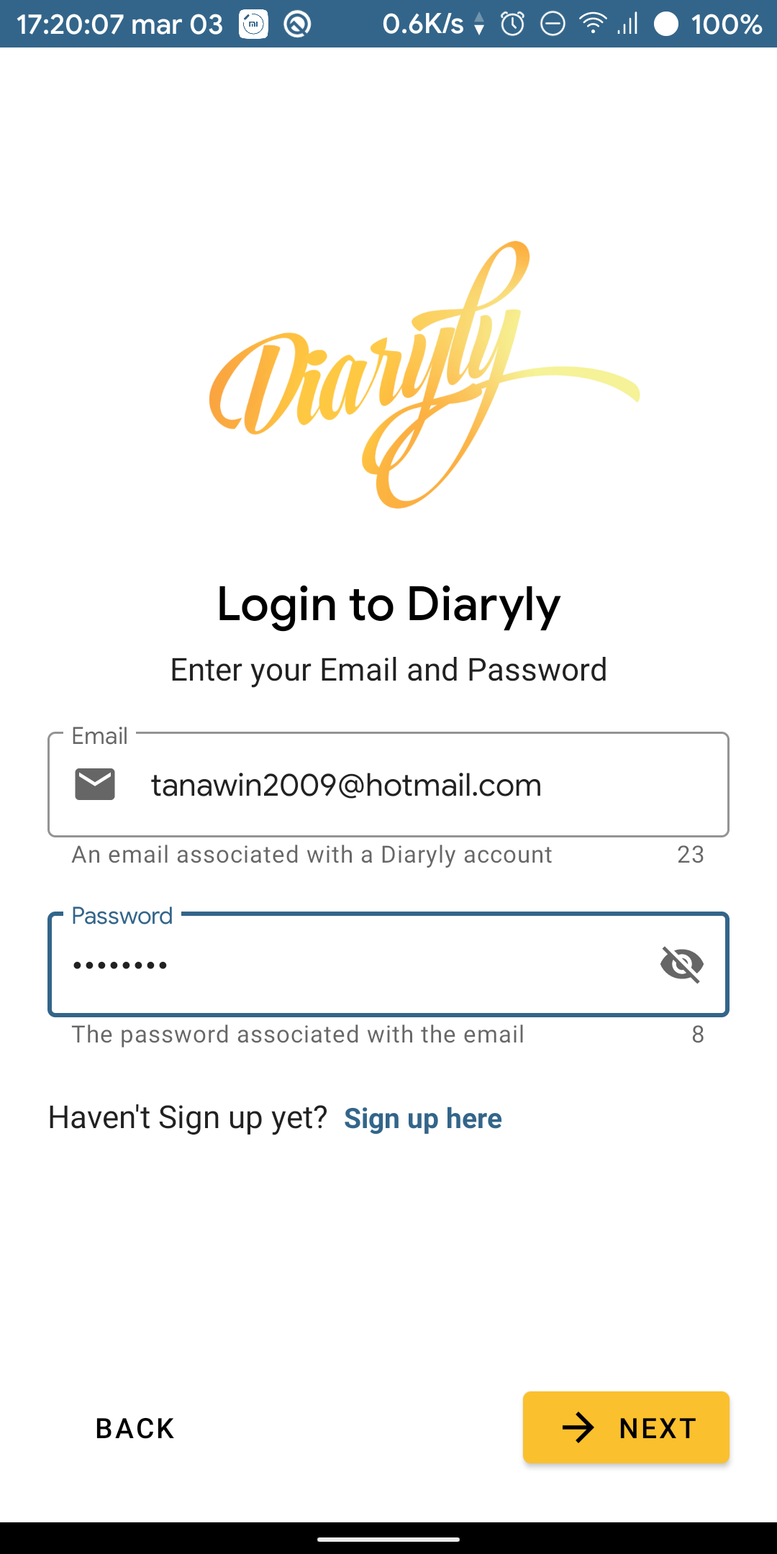

Figure Login Page

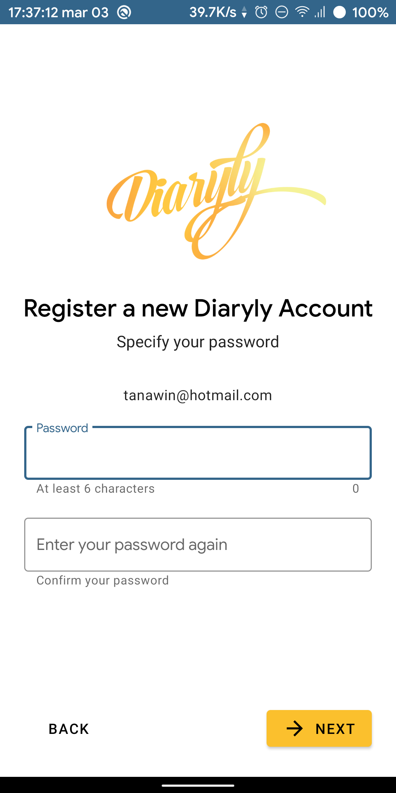

Figure 14 Password Registration



Figure 10 Password Error

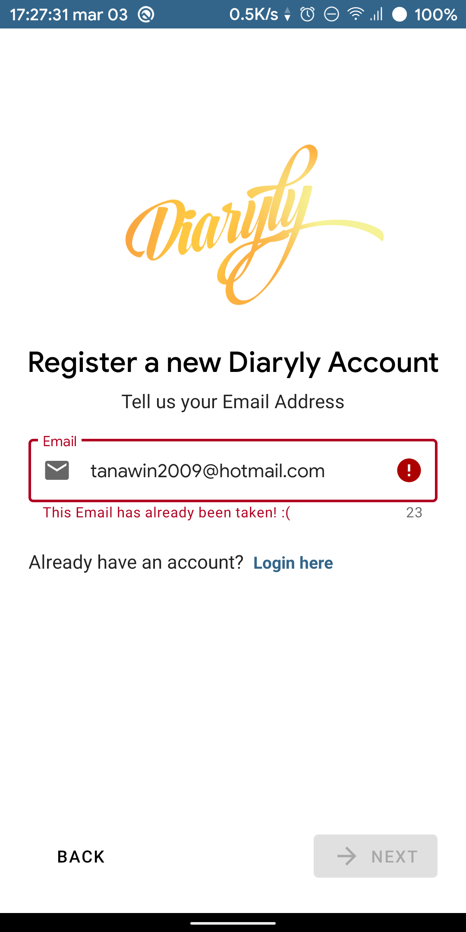

Figure 11 Invalid Email

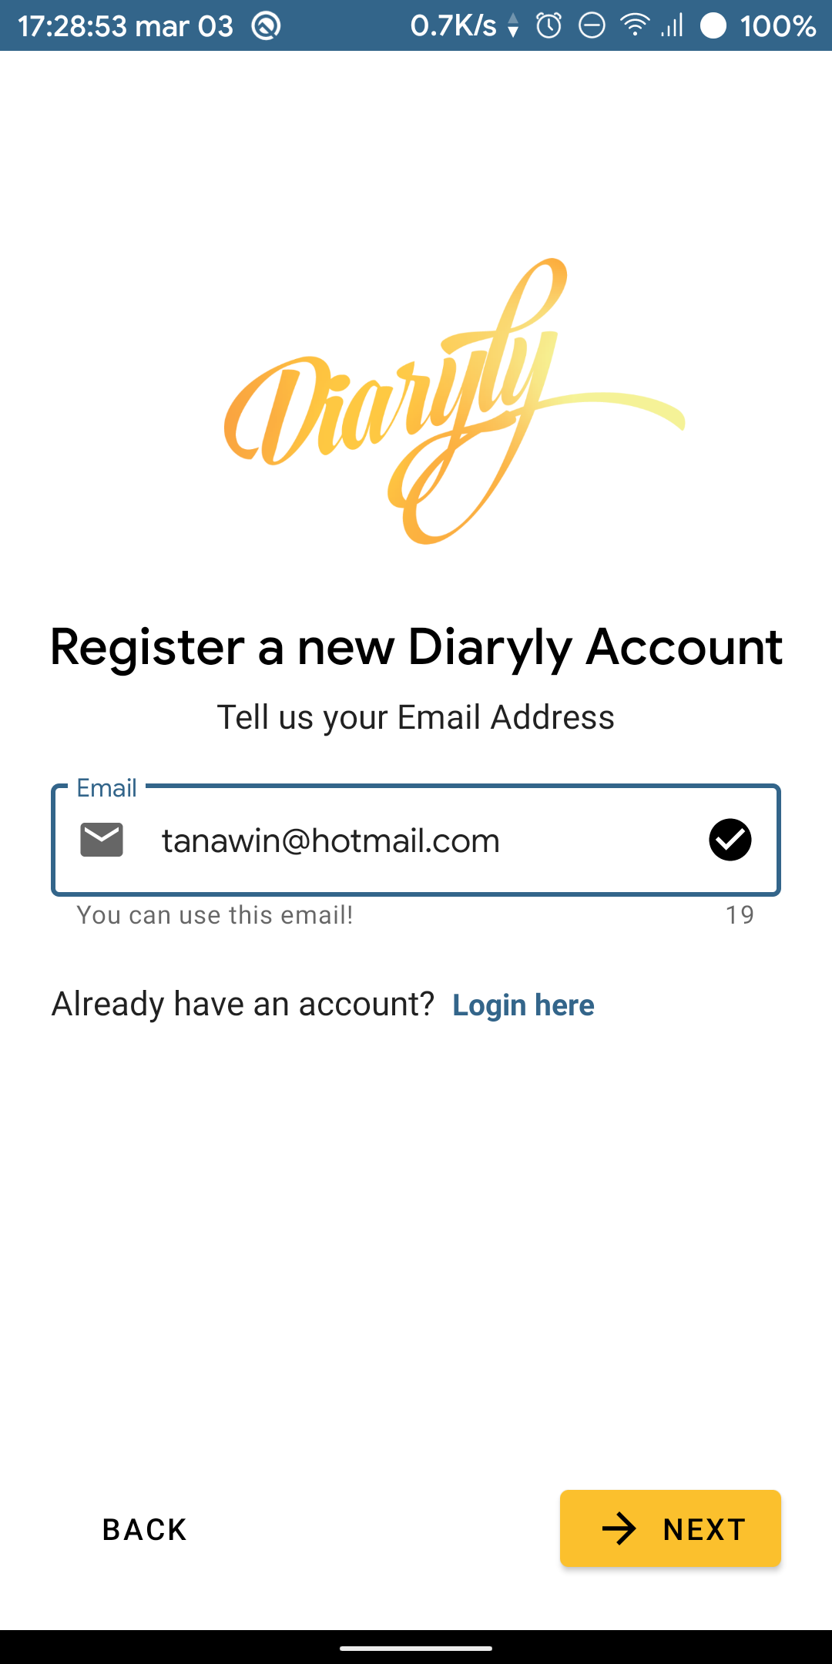

Figure 12 Valid Email entered

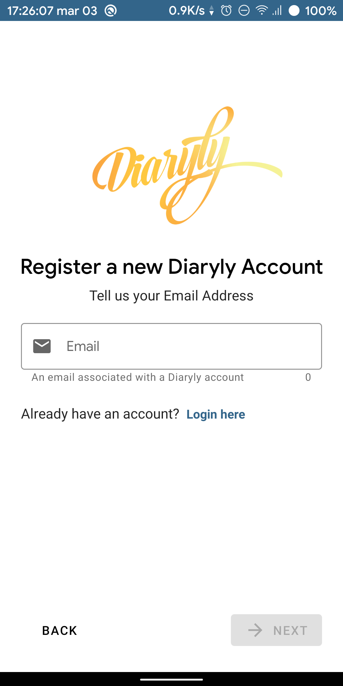

Figure 13 First Register page

On the other hand, if the user already has an account and wants to log in, they can do so by directly entering the login page (figure 15). Similar to both register pages, the login page also has a progress indication (figure 16) and a rich error handling (Figure 17). After the user entered a valid email address and a valid password and pressed the next button, they will be redirected to the main page of the app (figure 18).

Figure 18 the Main Page of the app

## **EntryEditActivity**

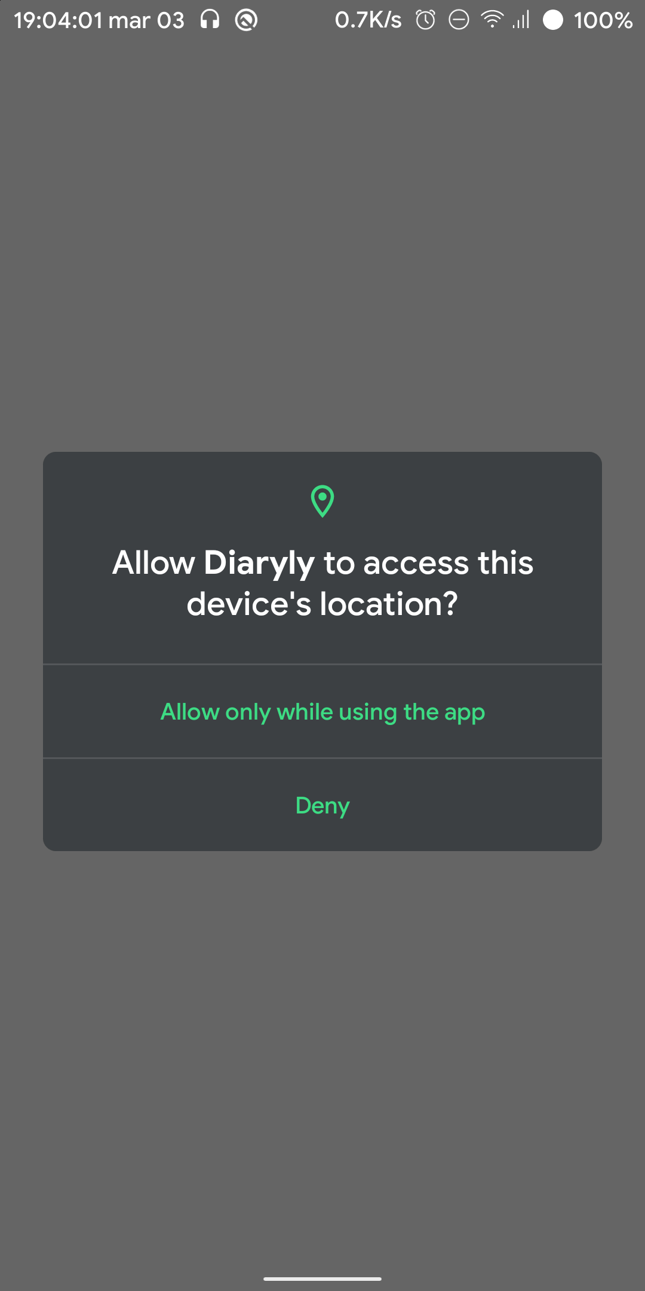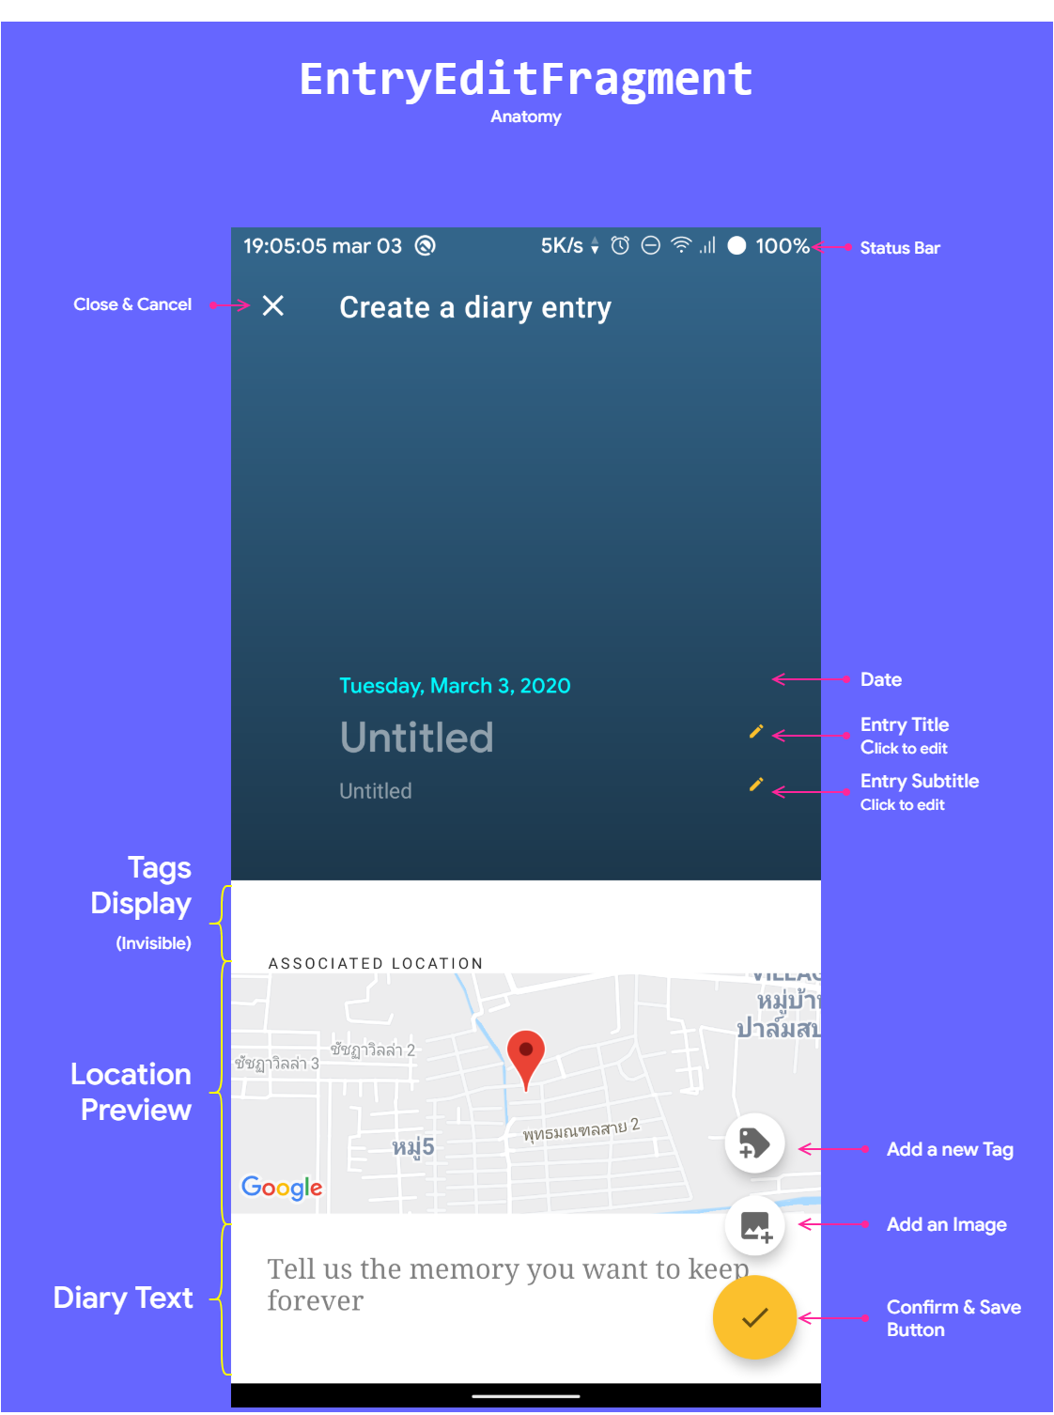EntryEditActivity is an activity that hosts a fragment named EntryEditFragment. EntryEditFragment allows users to add a new diary entry that can consist of an image, text, geolocation coordinate and tags. EntryEditActivity can be accessed from the main page by using the add floating action button on the bottom right corner (figure 18).

When a user enters this activity for the first time, the user will be asked for location permission. →

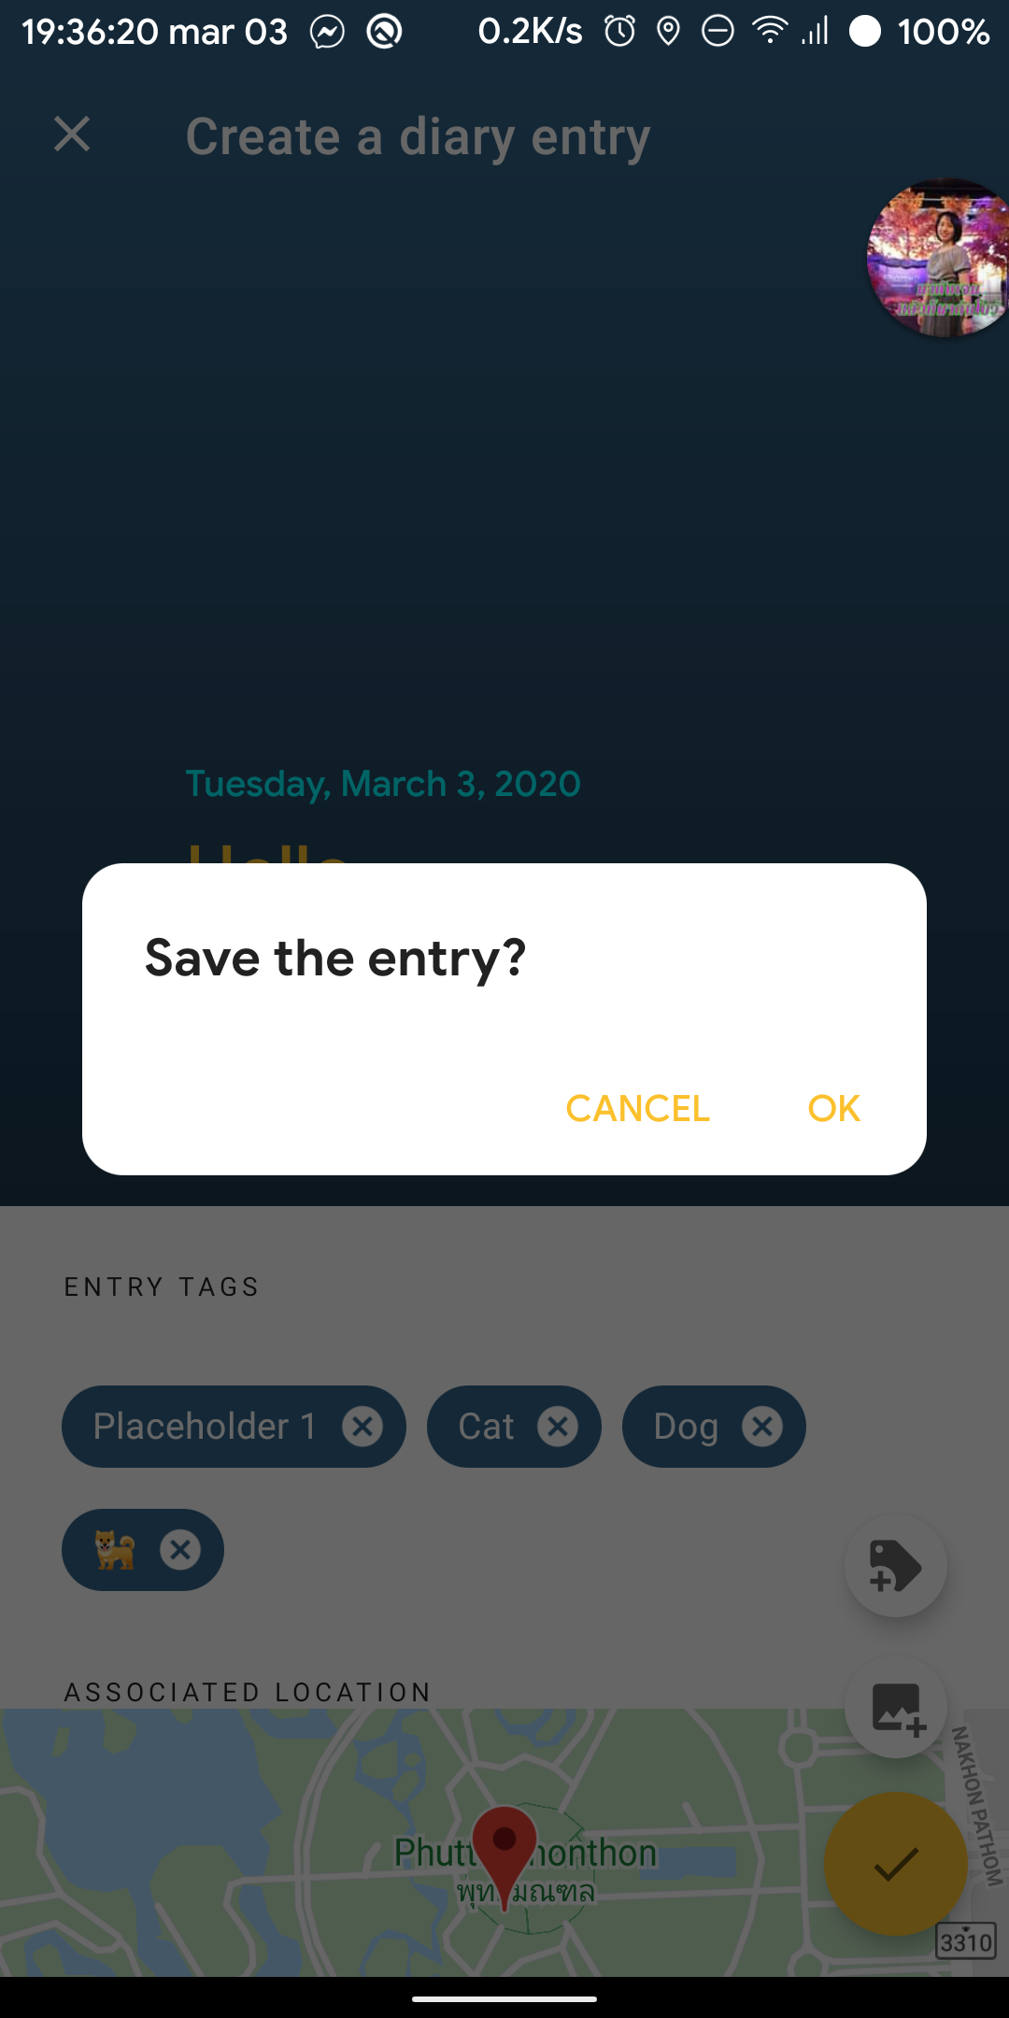

← When the user wants to confirm or cancel the creation, a dialog will be displayed to ask the user for confirmation.

### Editing Title or Subtitle

Tap on the “untitled” text or the pencil icon of either title or subtitle. A text dialog will be displayed.

### Adding a Tag

Tap on the “Add a new tag” icon. A dialog will ask a user to enter a tag name. If the user confirms, a new section called “Entry Tag” and a new Tag Chip will be visible on the screen.

### Removing a Tag

To remove a tag, a user can tap on the cross icon on each Tag Chip.

### Adding an Image

To add a new image, a user can tap on the colored space beneath the title or the “Add an image” button. The app will allow the user to select an image or photo from other gallery apps. When an image or photo is selected, the image will be displayed.

### Removing an Image

Tap on the “Add an image” button again.

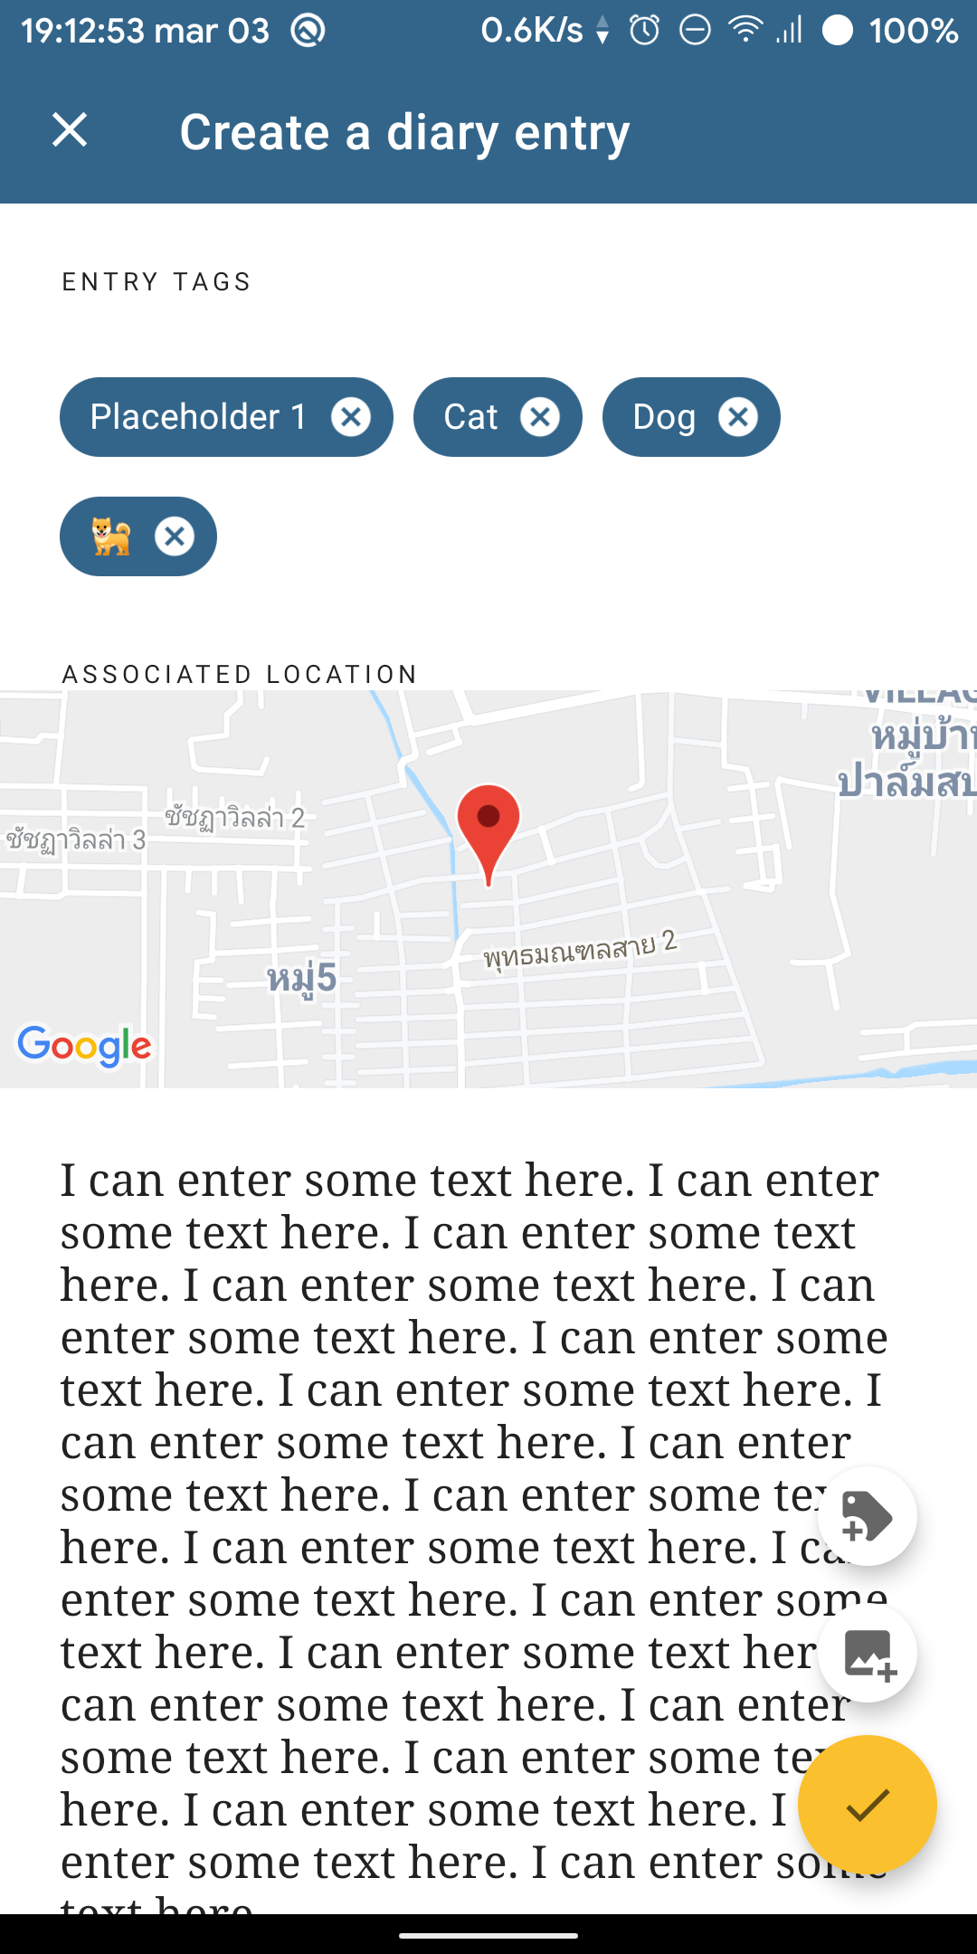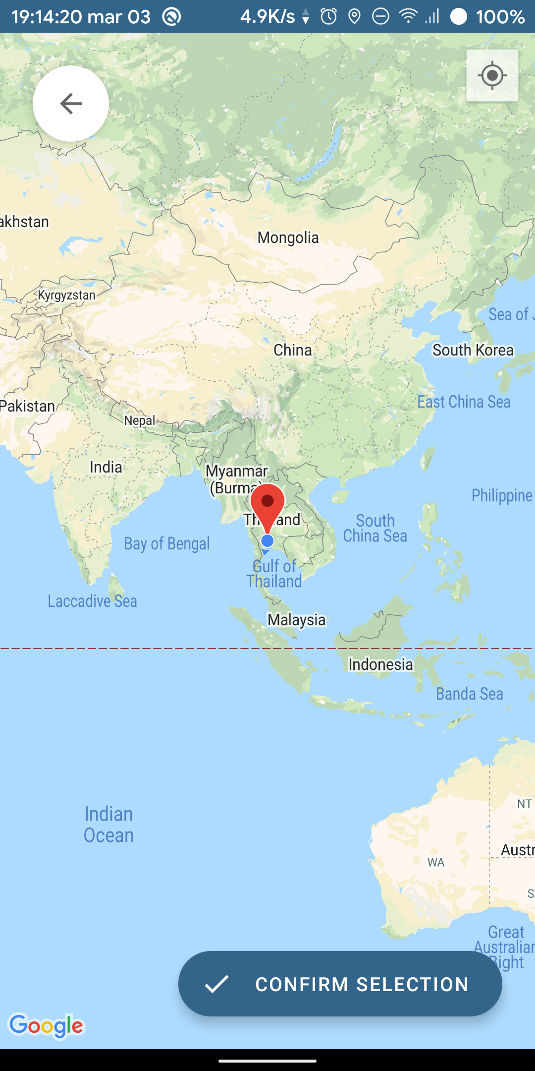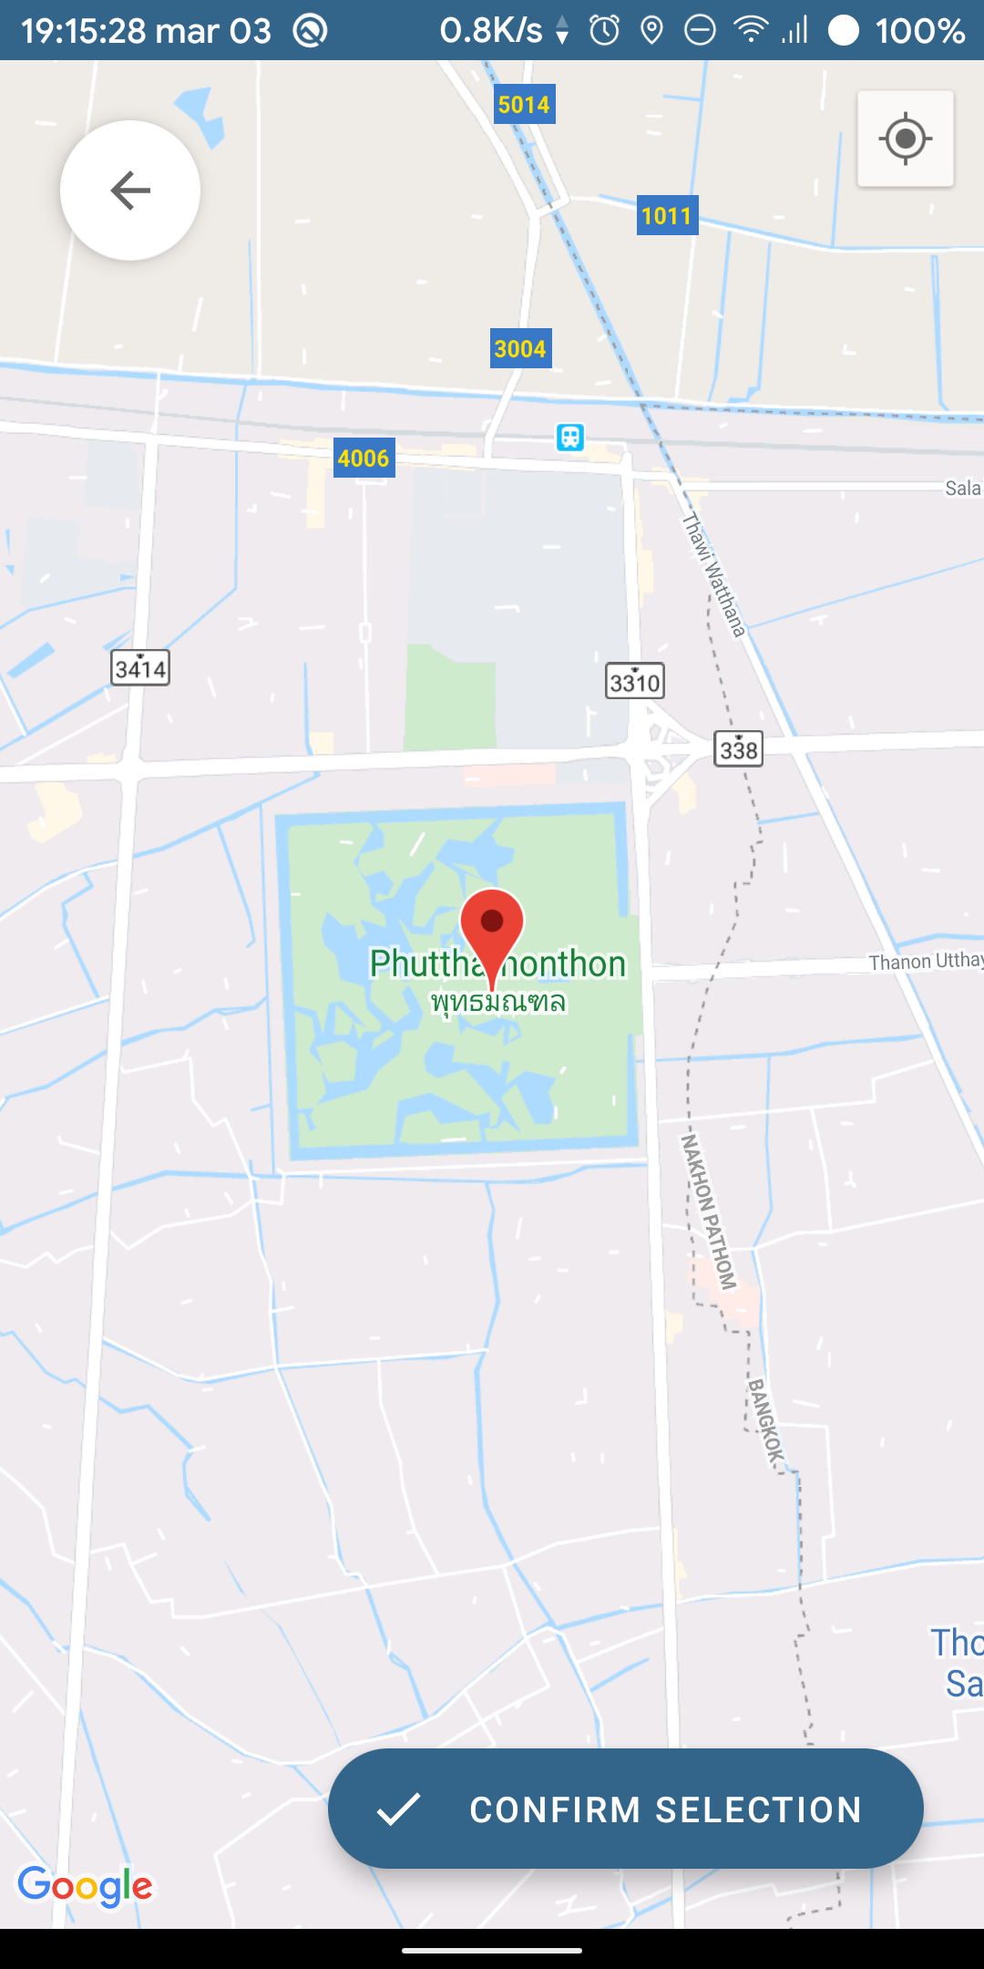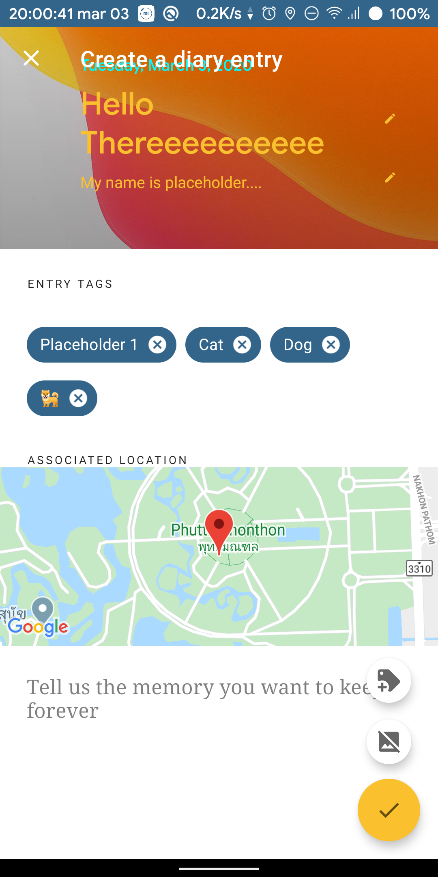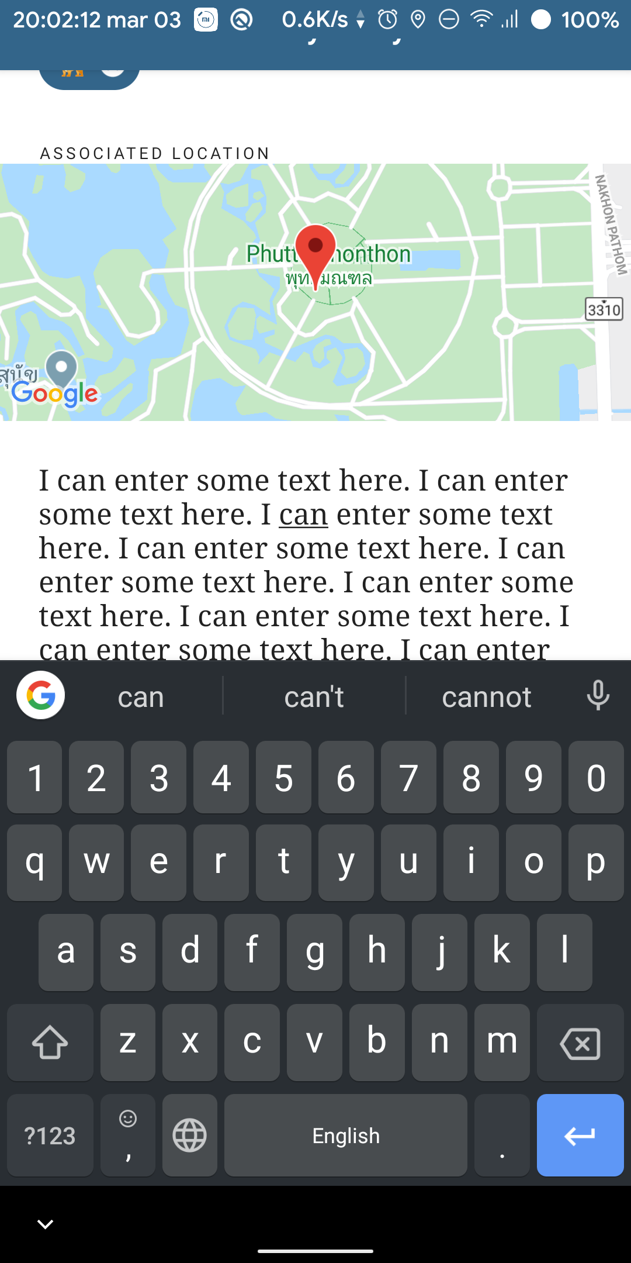

### Edit an entry tag

A user can freely edit their text using the **TextEdit** we provided below the map.

### Adding a location

Tap on the Location Preview will redirect user to the **LocationActivity** which contains a map that allow user to tap on to select a location. When confirmed, the location will be return back to **EntryEditActivity**.